**Minimalist Environments**

Mirror’s Edge:

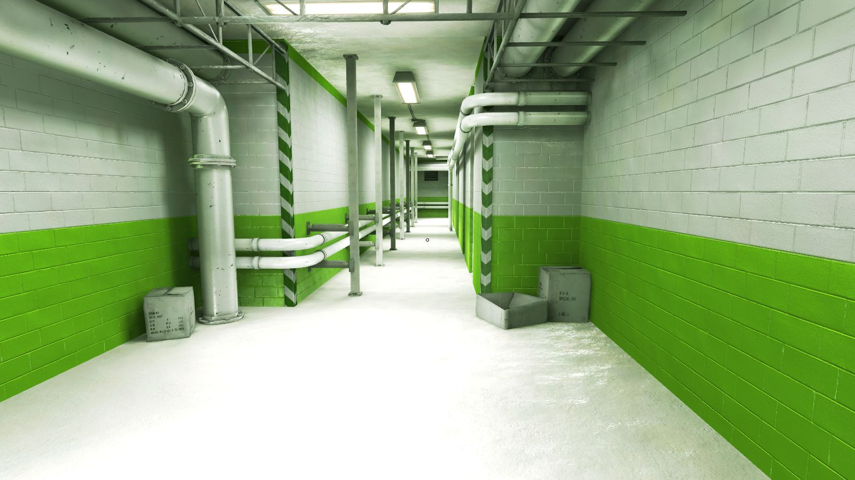

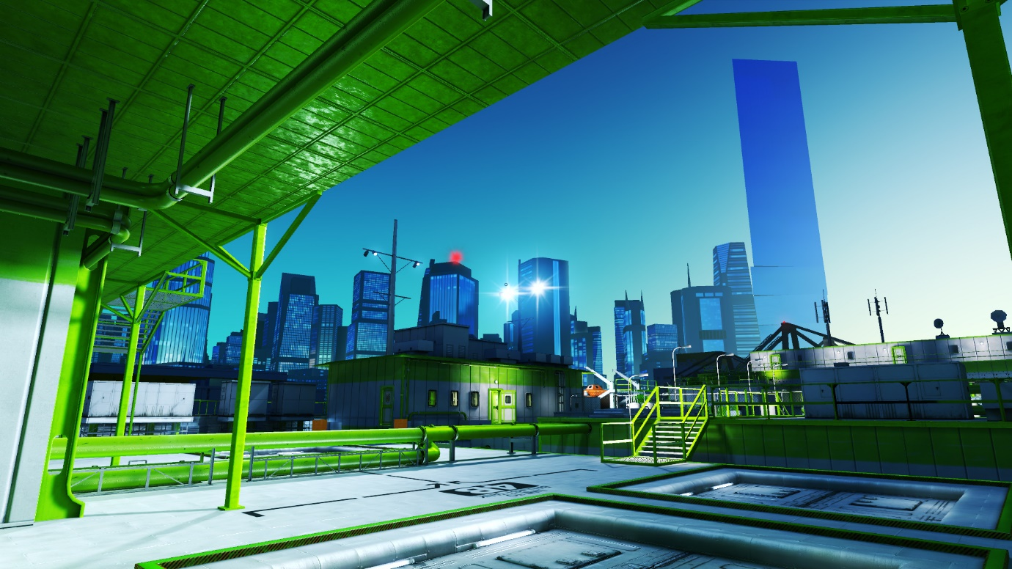

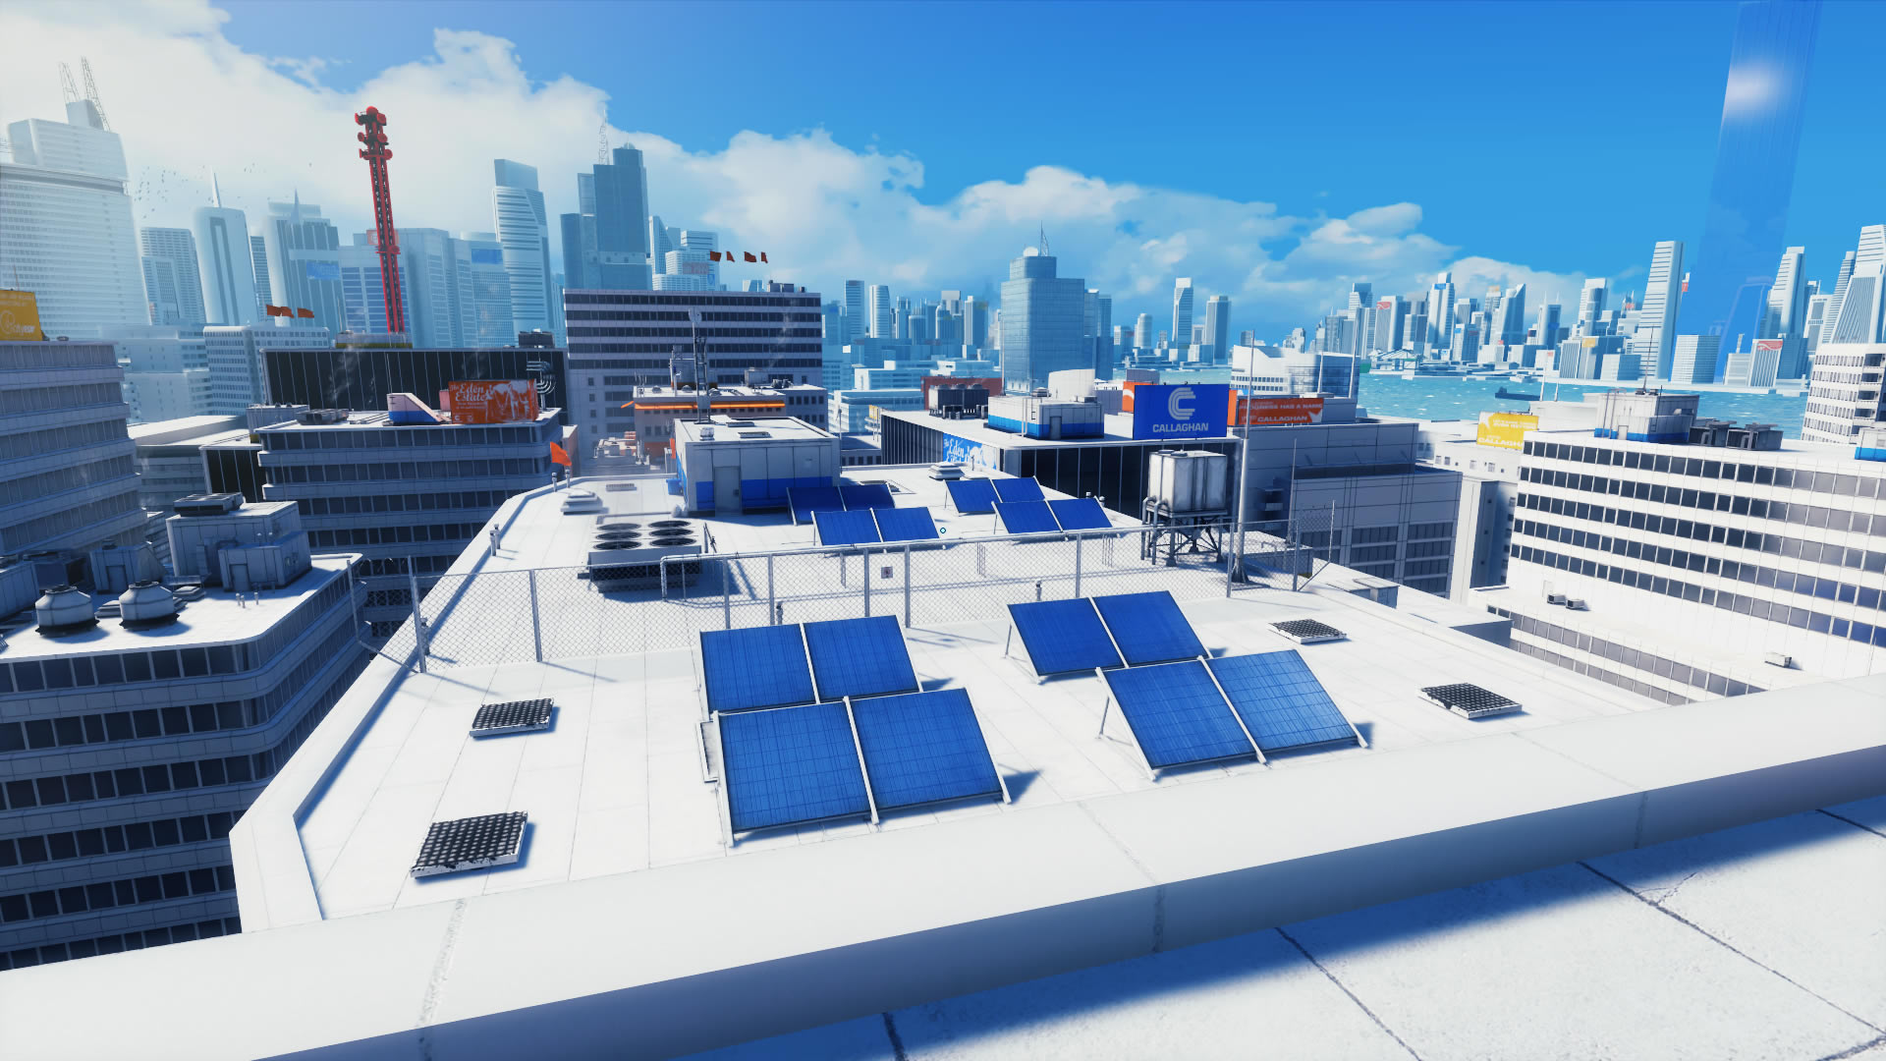

Whilst the environments of Mirror’s Edge are rendered in a realistic style, the simplistic colour scheme evokes a feeling of minimalism, as the environments aren’t meant to be photo-realistic and therefore aren’t overly detailed. Through this design choice, the developers (DICE) managed to create a unique way of highlighting the path through the levels to the player by highlighting the path in red, which contrasts with the otherwise bright white environments commonly seen within the game.

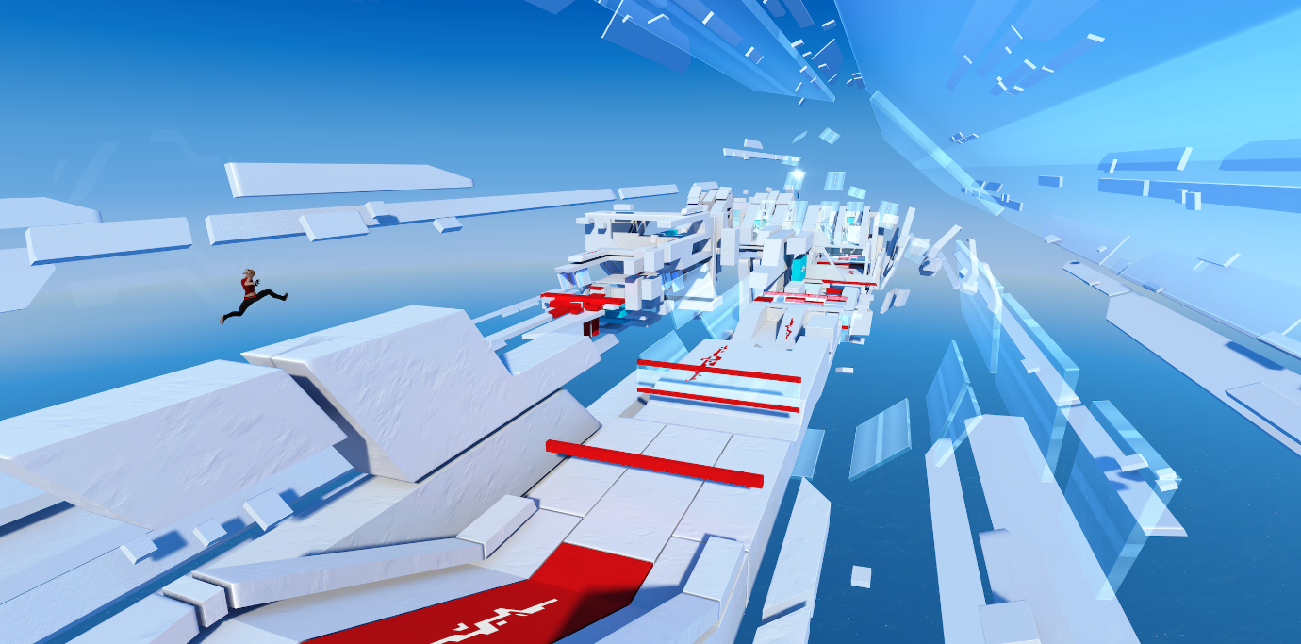

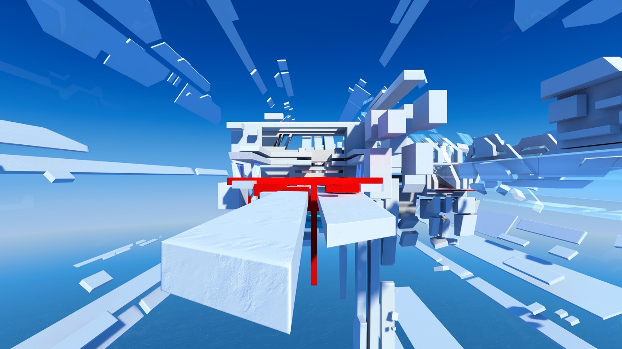

Mirror’s Edge digs deeper into the idea of minimalistic level design in the various time trial DLC packs released for the game after its release. In these DLC packs, the player is challenged to complete an obstacle course in the fastest time possible. In these DLC time trials, however, the levels have been reduced to raw shapes rather than things like buildings. The simplistic colour scheme also remains, creating a truly minimalist environment for the player to traverse.

**The Stanley Parable**

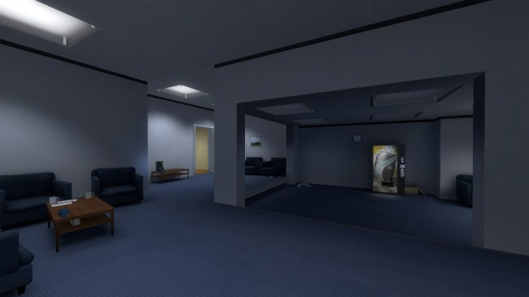

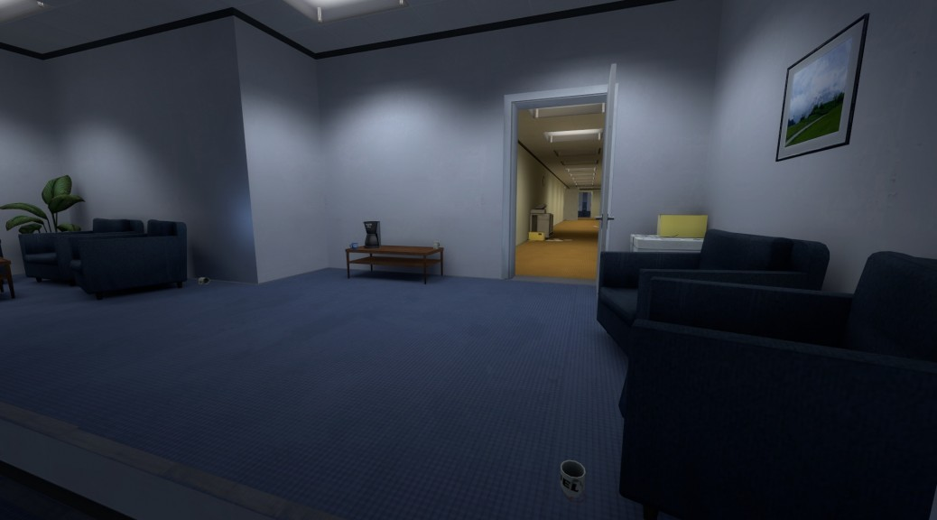

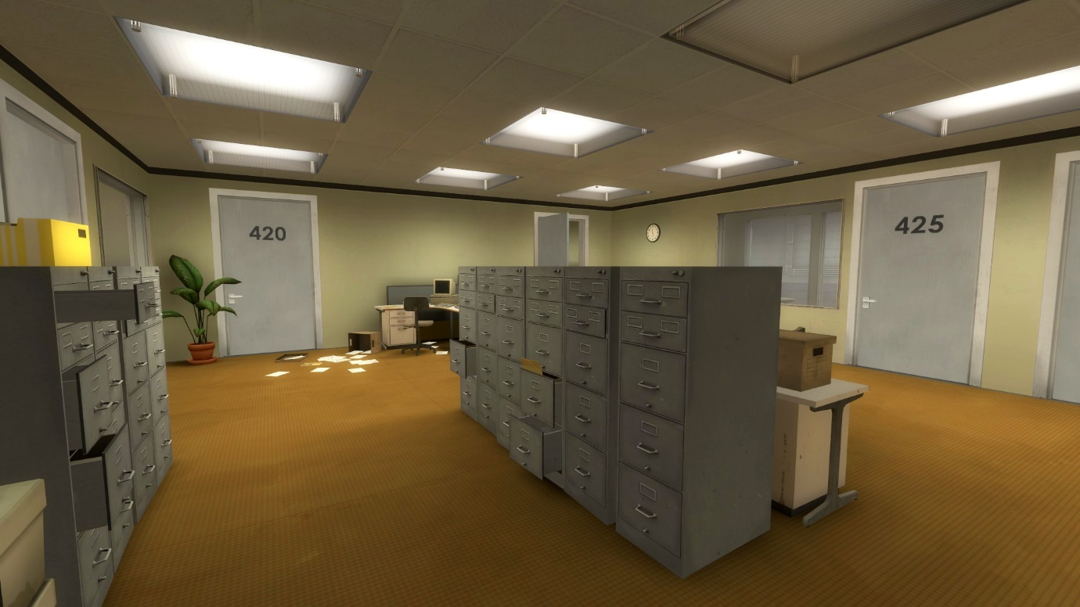

The environments found in The Stanley Parable are, for the most part, quite minimalistic. This is owed to the fact that each area has a very straightforward layout and shape. These qualities, along with the art style of the game, can make the minimalistic style of the environments quite similar to that of Mirror’s Edge in that, whilst detailed to an extent, they aren’t flashy or overly detailed. Instead, they contain the minimum amount of detail required to create a functional environment.

**Portal-Aperture training facility**

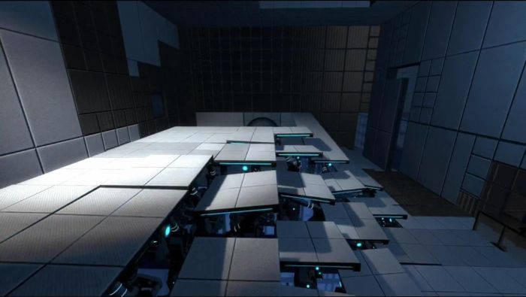

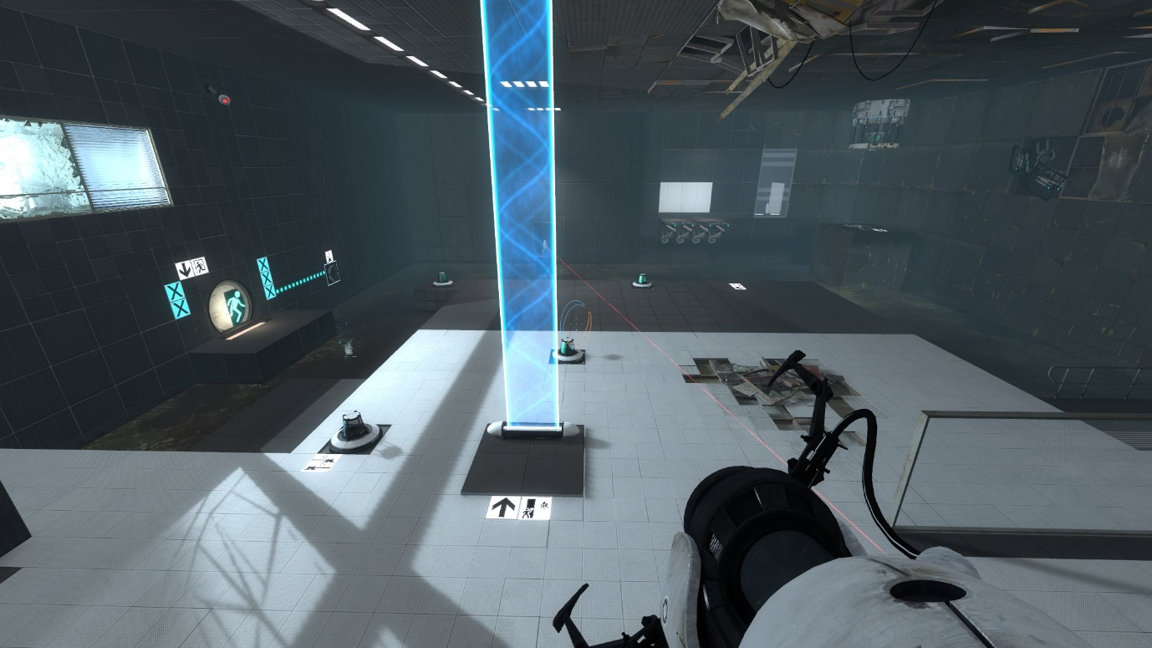

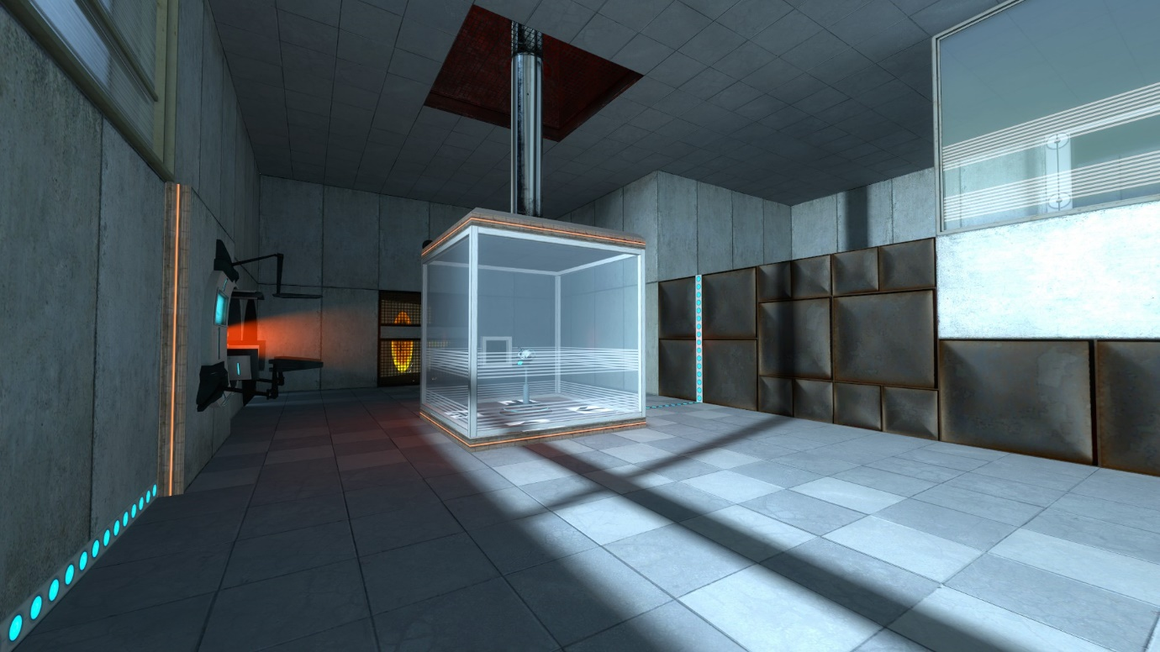

As with the last 2 games I have mentioned, the Aperture Science Training Facility from Portal has a very minimalistic design. Despite the game being a complex puzzle based platformer, the environments are very minimalistic in nature if you look past the puzzles. The levels all have a very simple design and layout and feature a very basic colour scheme which somewhat enforces the minimalistic design of the levels. The simple layout of the levels combined with the complex puzzles and function of the portal gun is what comes together to create the challenging platforming gameplay of portal.